**TABLE OF SPECIFICATIONS FOR EXAM QUESTIONS**

**University of Liberal Arts Bangladesh**

**Department: Computer Science and Engineering (CSE)**

**Midterm Examinations, Semester: Summer 2020**

**Program: B.Sc. in CSE**

**Course Code: CSE417 Course Title: Automata and Theory of Computation Credit Hr: 3**

**Time: 1 Hours Total Marks: 25**

**Name & Designation of the Examiner: Satyaki Das, Lecturer**

**Learning Outcomes (LO):**

|  |
| --- |
| 1. **Describe** the principles and concept of automata along with its benefits. |
| 1. **Explain** features of state machines to design and develop solutions |
| 1. **Solve** a wide range of practical problems for automata and formal languages. |
| 1. **Understand** real-life problem and **be able** to design the solution using automata. |
| 1. **Design and develop** solutions to real-life problems. |

***Levels in Bloom’s Cognitive Domain:***

***C1: Remember C2: Understand C3: Apply C4: Analyze C5: Evaluate C6: Create***

|  |  |  |  |  |  |  |  |
| --- | --- | --- | --- | --- | --- | --- | --- |
| **Question No.** | **Learning Outcomes (CO)** | **Level in Bloom’s Cognitive Domain along with Allocation of Marks** | | | | | |
|  |  | **C1** | **C2** | **C3** | **C4** | **C5** | **C6** |
| 1 | 1, 2 | 2 | 3 |  |  |  |  |
| 2 | 1, 2 |  |  | 3 | 2 |  |  |
| 3 | 1, 2, 3 | 1 | 2 |  | 4 |  |  |
| 4 | 1, 2, 3 | 1 | 2 | 5 |  |  |  |
| **Total Allocation of Marks** | **25** | 4 | 7 | 8 | 6 |  |  |
|  |  |  |  |  |  |  |  |
| **Question No.** |  | **Learning Outcome** | | | | | |
|  |  | **CO1** | **CO2** | **CO3** | **CO4** | **CO5** | **CO6** |
| 1 |  | 3 | 2 |  |  |  |  |
| 2 |  | 3 | 2 |  |  |  |  |
| 3 |  | 1 | 2 | 4 |  |  |  |
| 4 |  | 1 | 2 | 5 |  |  |  |
| **Total Allocation of Marks** | **25** | 8 | 8 | 9 |  |  |  |



**Signature of the Examiner Date: 12.08.2020**

**Department of Computer Science and Engineering**

**University of Liberal Arts Bangladesh**

**Mid-Term Examination (Summer 2020)**

**Course: Automata and Theory of Computation (CSE 417)**

**Section: 2 --- Duration: 1 Hour**

**______________________________________________________________________________________**

**PLEASE ANSWER ALL QUESTIONS. Total 25 Marks**

**QUESTION 1**

What are the 5-tuples of a DFA?

What is the difference between the formal definitions of DFA, NFA and Ɛ-NFA? Explain with a suitable example. **(2+3=5 Marks)**

**QUESTION 2**

Consider the following Ɛ-NFA:

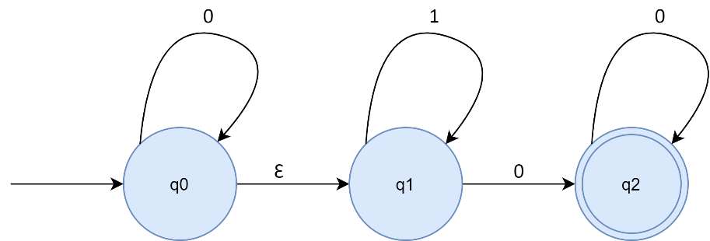

Convert the Ɛ-NFA to its equivalent NFA.

What will be the output for inputs “000” and “111”? **(3+2=5 Marks)**

**QUESTION 3**

Define the transition function, δ for an NFA.

“All DFAs are by definition an NFA”- Explain

Suppose you are trying to develop a game where the user starts from the center (0,0) of a standard cartesian coordinate system. The user can either move up (denoted by U/↑) or he can move right (denoted by R/→). Assume the user wins the game if s/he reaches (2,1). Design the NFA that can determine if the user wins the game. Provide, Q, Σ, q0, and F. **(1+2+4=7 Marks)**

**QUESTION 4**

Prepare the state transition table for the NFA you designed. Convert it to its equivalent DFA.

How would you convert a DFA to its equivalent NFA?

Is it possible for a DFA to have more than one final state? **(5+2+1=8 Marks)**

**\*\*END OF QUESTIONS\*\***